1 run......

training 1 epoch...

71.32092094421387 seconds used......

1 training finished! average train loss: 0.9961994556444032

evaluating...

Confusion matrix, without normalization

[[ 82 25 17]

[ 39 117 8]

[404 90 371]]

Normalized confusion matrix

[[0.66129032 0.2016129 0.13709677]

[0.23780488 0.71341463 0.04878049]

[0.46705202 0.10404624 0.42890173]]

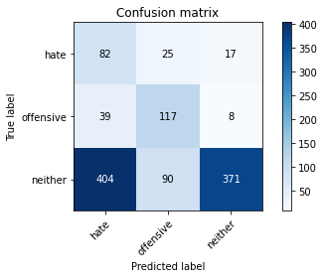

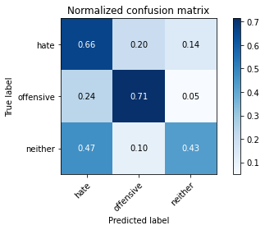

precision recall f1-score support

hate 0.16 0.66 0.25 124

offensive 0.50 0.71 0.59 164

neither 0.94 0.43 0.59 865

accuracy 0.49 1153

macro avg 0.53 0.60 0.48 1153

weighted avg 0.79 0.49 0.55 1153

average eval_loss: 0.9034396872438234, accuracy: 0.4943625325238508

training 2 epoch...

70.42450499534607 seconds used......

2 training finished! average train loss: 0.8524927851699647

evaluating...

Confusion matrix, without normalization

[[ 96 22 6]

[ 50 110 4]

[495 67 303]]

Normalized confusion matrix

[[0.77419355 0.17741935 0.0483871 ]

[0.30487805 0.67073171 0.02439024]

[0.57225434 0.07745665 0.35028902]]

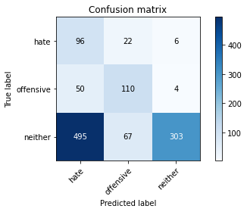

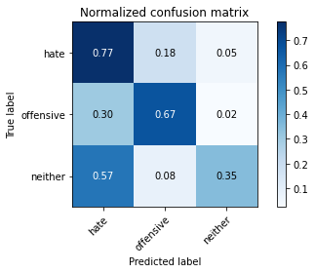

precision recall f1-score support

hate 0.15 0.77 0.25 124

offensive 0.55 0.67 0.61 164

neither 0.97 0.35 0.51 865

accuracy 0.44 1153

macro avg 0.56 0.60 0.46 1153

weighted avg 0.82 0.44 0.50 1153

average eval_loss: 0.9263882462320656, accuracy: 0.4414570685169124

training 3 epoch...

70.38632345199585 seconds used......

3 training finished! average train loss: 0.7008699929075581

evaluating...

Confusion matrix, without normalization

[[ 61 22 41]

[ 27 109 28]

[195 55 615]]

Normalized confusion matrix

[[0.49193548 0.17741935 0.33064516]

[0.16463415 0.66463415 0.17073171]

[0.22543353 0.06358382 0.71098266]]

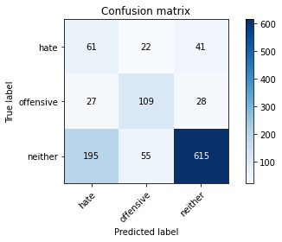

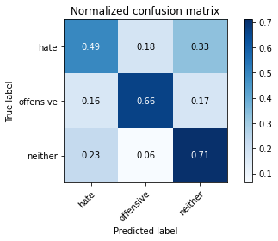

precision recall f1-score support

hate 0.22 0.49 0.30 124

offensive 0.59 0.66 0.62 164

neither 0.90 0.71 0.79 865

accuracy 0.68 1153

macro avg 0.57 0.62 0.57 1153

weighted avg 0.78 0.68 0.72 1153

average eval_loss: 0.7259937514518869, accuracy: 0.6808326105810928

training 4 epoch...

70.41974210739136 seconds used......

4 training finished! average train loss: 0.4569084267353728

evaluating...

Confusion matrix, without normalization

[[ 68 26 30]

[ 23 116 25]

[298 68 499]]

Normalized confusion matrix

[[0.5483871 0.20967742 0.24193548]

[0.1402439 0.70731707 0.15243902]

[0.34450867 0.07861272 0.57687861]]

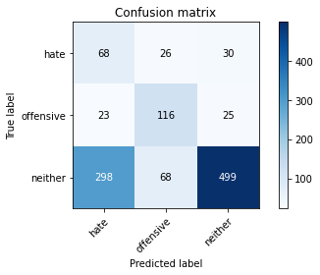

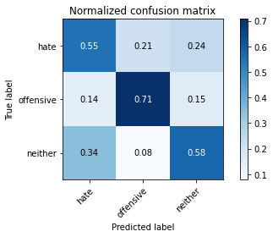

precision recall f1-score support

hate 0.17 0.55 0.27 124

offensive 0.55 0.71 0.62 164

neither 0.90 0.58 0.70 865

accuracy 0.59 1153

macro avg 0.54 0.61 0.53 1153

weighted avg 0.77 0.59 0.64 1153

average eval_loss: 0.9336658274305278, accuracy: 0.5923677363399826

training 5 epoch...

70.44630479812622 seconds used......

5 training finished! average train loss: 0.2335253581848173

evaluating...

Confusion matrix, without normalization

[[ 80 17 27]

[ 44 109 11]

[380 69 416]]

Normalized confusion matrix

[[0.64516129 0.13709677 0.21774194]

[0.26829268 0.66463415 0.06707317]

[0.43930636 0.07976879 0.48092486]]

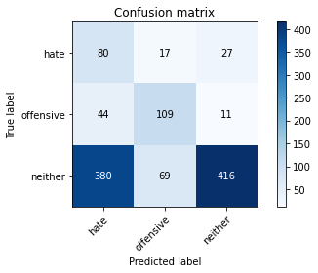

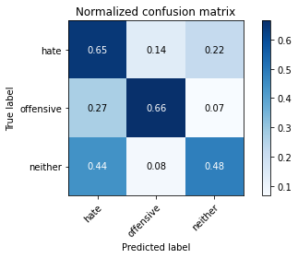

precision recall f1-score support

hate 0.16 0.65 0.25 124

offensive 0.56 0.66 0.61 164

neither 0.92 0.48 0.63 865

accuracy 0.52 1153

macro avg 0.54 0.60 0.50 1153

weighted avg 0.78 0.52 0.59 1153

average eval_loss: 1.4555279550881222, accuracy: 0.5247181266261925

training 6 epoch...

70.43791127204895 seconds used......

6 training finished! average train loss: 0.12170473260006734

evaluating...

Confusion matrix, without normalization

[[ 82 20 22]

[ 39 111 14]

[382 61 422]]

Normalized confusion matrix

[[0.66129032 0.16129032 0.17741935]

[0.23780488 0.67682927 0.08536585]

[0.4416185 0.07052023 0.48786127]]

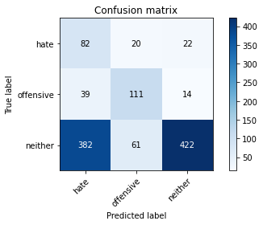

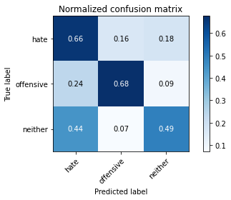

precision recall f1-score support

hate 0.16 0.66 0.26 124

offensive 0.58 0.68 0.62 164

neither 0.92 0.49 0.64 865

accuracy 0.53 1153

macro avg 0.55 0.61 0.51 1153

weighted avg 0.79 0.53 0.60 1153

average eval_loss: 1.7158005669199188, accuracy: 0.5333911535125759

training 7 epoch...

70.41802406311035 seconds used......

7 training finished! average train loss: 0.07208899109502367

evaluating...

Confusion matrix, without normalization

[[ 75 18 31]

[ 37 108 19]

[333 59 473]]

Normalized confusion matrix

[[0.60483871 0.14516129 0.25 ]

[0.22560976 0.65853659 0.11585366]

[0.3849711 0.06820809 0.54682081]]

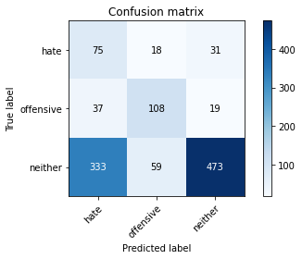

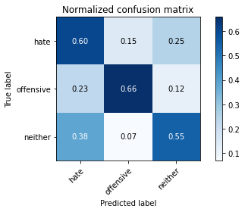

precision recall f1-score support

hate 0.17 0.60 0.26 124

offensive 0.58 0.66 0.62 164

neither 0.90 0.55 0.68 865

accuracy 0.57 1153

macro avg 0.55 0.60 0.52 1153

weighted avg 0.78 0.57 0.63 1153

average eval_loss: 1.8069860842721215, accuracy: 0.5689505637467476

training 8 epoch...

70.49334406852722 seconds used......

8 training finished! average train loss: 0.04765741676480199

evaluating...

Confusion matrix, without normalization

[[ 85 14 25]

[ 61 88 15]

[386 53 426]]

Normalized confusion matrix

[[0.68548387 0.11290323 0.2016129 ]

[0.37195122 0.53658537 0.09146341]

[0.44624277 0.06127168 0.49248555]]

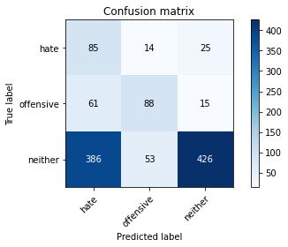

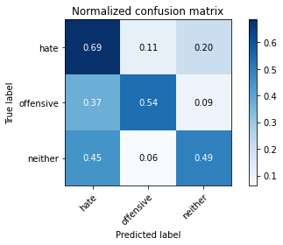

precision recall f1-score support

hate 0.16 0.69 0.26 124

offensive 0.57 0.54 0.55 164

neither 0.91 0.49 0.64 865

accuracy 0.52 1153

macro avg 0.55 0.57 0.48 1153

weighted avg 0.78 0.52 0.59 1153

average eval_loss: 2.2548481390394013, accuracy: 0.5195143104943626

training 9 epoch...

70.42491555213928 seconds used......

9 training finished! average train loss: 0.04880774188703591

evaluating...

Confusion matrix, without normalization

[[ 81 24 19]

[ 40 109 15]

[385 95 385]]

Normalized confusion matrix

[[0.65322581 0.19354839 0.15322581]

[0.24390244 0.66463415 0.09146341]

[0.44508671 0.10982659 0.44508671]]

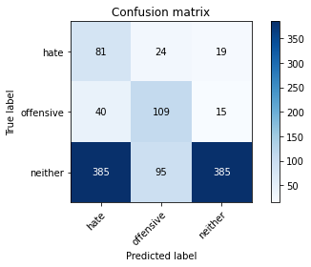

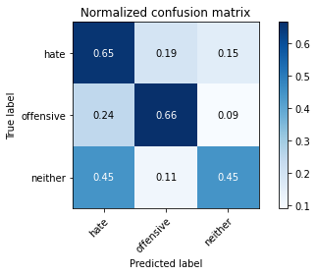

precision recall f1-score support

hate 0.16 0.65 0.26 124

offensive 0.48 0.66 0.56 164

neither 0.92 0.45 0.60 865

accuracy 0.50 1153

macro avg 0.52 0.59 0.47 1153

weighted avg 0.77 0.50 0.56 1153

average eval_loss: 2.5113292932510376, accuracy: 0.4986990459670425

training 10 epoch...

70.43768429756165 seconds used......

10 training finished! average train loss: 0.04572503089106509

evaluating...

Confusion matrix, without normalization

[[ 74 30 20]

[ 34 116 14]

[318 115 432]]

Normalized confusion matrix

[[0.59677419 0.24193548 0.16129032]

[0.20731707 0.70731707 0.08536585]

[0.36763006 0.13294798 0.49942197]]

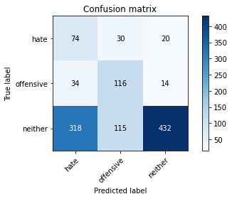

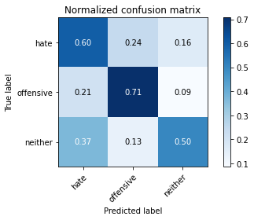

precision recall f1-score support

hate 0.17 0.60 0.27 124

offensive 0.44 0.71 0.55 164

neither 0.93 0.50 0.65 865

accuracy 0.54 1153

macro avg 0.52 0.60 0.49 1153

weighted avg 0.78 0.54 0.59 1153

average eval_loss: 2.238662565576619, accuracy: 0.5394622723330442

2 run......

training 1 epoch...

70.4001202583313 seconds used......

1 training finished! average train loss: 0.997755072656132

evaluating...

Confusion matrix, without normalization

[[ 54 37 33]

[ 16 127 21]

[220 133 512]]

Normalized confusion matrix

[[0.43548387 0.2983871 0.26612903]

[0.09756098 0.77439024 0.12804878]

[0.25433526 0.15375723 0.59190751]]

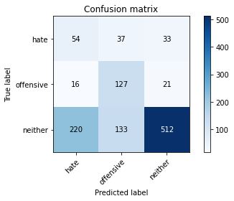

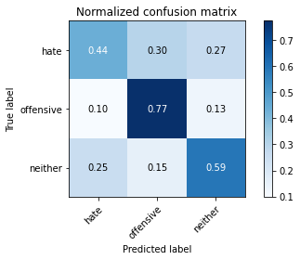

precision recall f1-score support

hate 0.19 0.44 0.26 124

offensive 0.43 0.77 0.55 164

neither 0.90 0.59 0.72 865

accuracy 0.60 1153

macro avg 0.51 0.60 0.51 1153

weighted avg 0.76 0.60 0.64 1153

average eval_loss: 0.8779228083018599, accuracy: 0.601040763226366

training 2 epoch...

70.40734267234802 seconds used......

2 training finished! average train loss: 0.8560938966416177

evaluating...

Confusion matrix, without normalization

[[ 96 25 3]

[ 45 117 2]

[630 93 142]]

Normalized confusion matrix

[[0.77419355 0.2016129 0.02419355]

[0.27439024 0.71341463 0.01219512]

[0.7283237 0.10751445 0.16416185]]

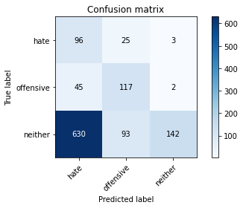

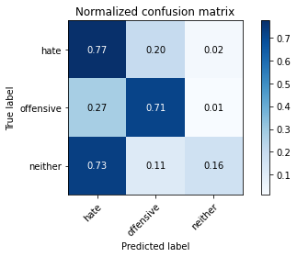

precision recall f1-score support

hate 0.12 0.77 0.21 124

offensive 0.50 0.71 0.59 164

neither 0.97 0.16 0.28 865

accuracy 0.31 1153

macro avg 0.53 0.55 0.36 1153

weighted avg 0.81 0.31 0.32 1153

average eval_loss: 1.0541401217723716, accuracy: 0.30789245446660884

training 3 epoch...

70.4049870967865 seconds used......

3 training finished! average train loss: 0.7036769459290164

evaluating...

Confusion matrix, without normalization

[[ 91 24 9]

[ 36 120 8]

[449 91 325]]

Normalized confusion matrix

[[0.73387097 0.19354839 0.07258065]

[0.2195122 0.73170732 0.04878049]

[0.51907514 0.10520231 0.37572254]]

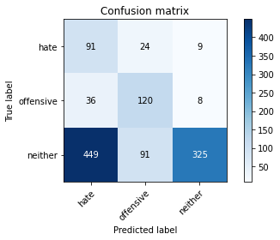

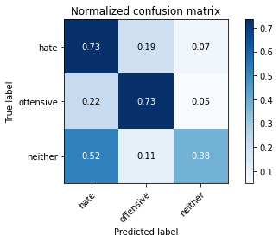

precision recall f1-score support

hate 0.16 0.73 0.26 124

offensive 0.51 0.73 0.60 164

neither 0.95 0.38 0.54 865

accuracy 0.46 1153

macro avg 0.54 0.61 0.47 1153

weighted avg 0.80 0.46 0.52 1153

average eval_loss: 1.1181818863441204, accuracy: 0.46487424111014747

training 4 epoch...

70.48139834403992 seconds used......

4 training finished! average train loss: 0.4258363155559415

evaluating...

Confusion matrix, without normalization

[[ 97 19 8]

[ 42 113 9]

[495 76 294]]

Normalized confusion matrix

[[0.78225806 0.15322581 0.06451613]

[0.25609756 0.68902439 0.05487805]

[0.57225434 0.08786127 0.33988439]]

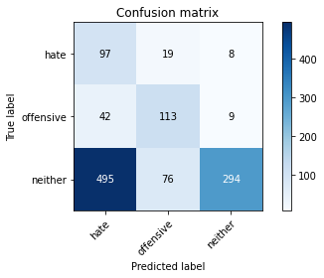

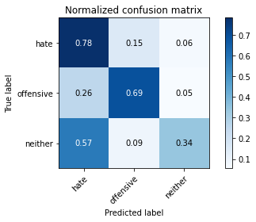

precision recall f1-score support

hate 0.15 0.78 0.26 124

offensive 0.54 0.69 0.61 164

neither 0.95 0.34 0.50 865

accuracy 0.44 1153

macro avg 0.55 0.60 0.45 1153

weighted avg 0.80 0.44 0.49 1153

average eval_loss: 1.4563344686195767, accuracy: 0.4371205550737207

training 5 epoch...

70.38487029075623 seconds used......

5 training finished! average train loss: 0.225388243461826

evaluating...

Confusion matrix, without normalization

[[ 97 16 11]

[ 45 110 9]

[430 69 366]]

Normalized confusion matrix

[[0.78225806 0.12903226 0.08870968]

[0.27439024 0.67073171 0.05487805]

[0.49710983 0.07976879 0.42312139]]

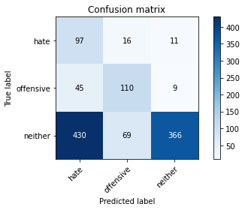

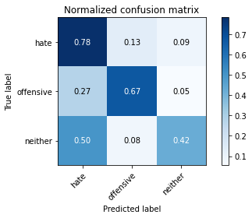

precision recall f1-score support

hate 0.17 0.78 0.28 124

offensive 0.56 0.67 0.61 164

neither 0.95 0.42 0.59 865

accuracy 0.50 1153

macro avg 0.56 0.63 0.49 1153

weighted avg 0.81 0.50 0.56 1153

average eval_loss: 1.559117278148388, accuracy: 0.49696444058976585

training 6 epoch...

70.45551109313965 seconds used......

6 training finished! average train loss: 0.11428809313413997

evaluating...

Confusion matrix, without normalization

[[ 91 21 12]

[ 45 108 11]

[453 85 327]]

Normalized confusion matrix

[[0.73387097 0.16935484 0.09677419]

[0.27439024 0.65853659 0.06707317]

[0.52369942 0.0982659 0.37803468]]

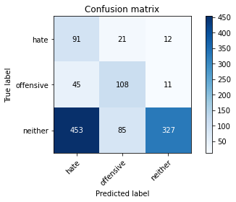

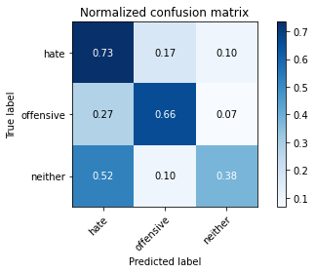

precision recall f1-score support

hate 0.15 0.73 0.26 124

offensive 0.50 0.66 0.57 164

neither 0.93 0.38 0.54 865

accuracy 0.46 1153

macro avg 0.53 0.59 0.45 1153

weighted avg 0.79 0.46 0.51 1153

average eval_loss: 2.058350180757457, accuracy: 0.4562012142237641

training 7 epoch...

70.34052276611328 seconds used......

7 training finished! average train loss: 0.07985270607362811

evaluating...

Confusion matrix, without normalization

[[ 85 31 8]

[ 38 115 11]

[428 97 340]]

Normalized confusion matrix

[[0.68548387 0.25 0.06451613]

[0.23170732 0.70121951 0.06707317]

[0.49479769 0.11213873 0.39306358]]

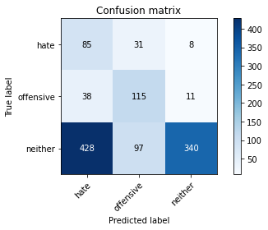

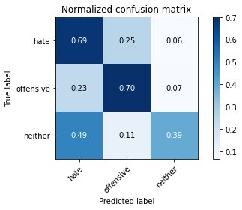

precision recall f1-score support

hate 0.15 0.69 0.25 124

offensive 0.47 0.70 0.57 164

neither 0.95 0.39 0.56 865

accuracy 0.47 1153

macro avg 0.52 0.59 0.46 1153

weighted avg 0.79 0.47 0.52 1153

average eval_loss: 2.314893418344958, accuracy: 0.4683434518647008

training 8 epoch...

70.46436977386475 seconds used......

8 training finished! average train loss: 0.048959208269869645

evaluating...

Confusion matrix, without normalization

[[ 64 29 31]

[ 26 114 24]

[243 76 546]]

Normalized confusion matrix

[[0.51612903 0.23387097 0.25 ]

[0.15853659 0.69512195 0.14634146]

[0.28092486 0.08786127 0.63121387]]

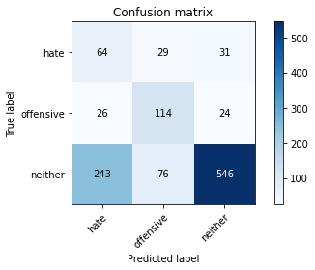

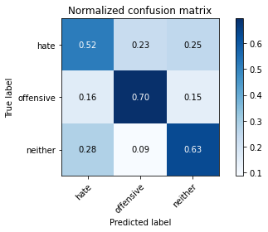

precision recall f1-score support

hate 0.19 0.52 0.28 124

offensive 0.52 0.70 0.60 164

neither 0.91 0.63 0.74 865

accuracy 0.63 1153

macro avg 0.54 0.61 0.54 1153

weighted avg 0.78 0.63 0.67 1153

average eval_loss: 1.5440712915412311, accuracy: 0.6279271465741544

training 9 epoch...

70.46641612052917 seconds used......

9 training finished! average train loss: 0.04024352419323155

evaluating...

Confusion matrix, without normalization

[[ 94 19 11]

[ 43 108 13]

[472 75 318]]

Normalized confusion matrix

[[0.75806452 0.15322581 0.08870968]

[0.26219512 0.65853659 0.07926829]

[0.54566474 0.0867052 0.36763006]]

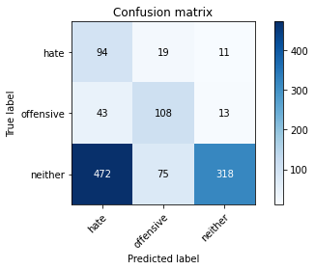

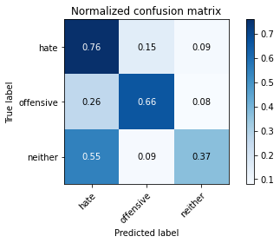

precision recall f1-score support

hate 0.15 0.76 0.26 124

offensive 0.53 0.66 0.59 164

neither 0.93 0.37 0.53 865

accuracy 0.45 1153

macro avg 0.54 0.59 0.46 1153

weighted avg 0.79 0.45 0.51 1153

average eval_loss: 2.641615995045366, accuracy: 0.45099739809193407

training 10 epoch...

70.41510796546936 seconds used......

10 training finished! average train loss: 0.027125926881646074

evaluating...

Confusion matrix, without normalization

[[ 85 16 23]

[ 49 100 15]

[298 60 507]]

Normalized confusion matrix

[[0.68548387 0.12903226 0.18548387]

[0.29878049 0.6097561 0.09146341]

[0.34450867 0.06936416 0.58612717]]

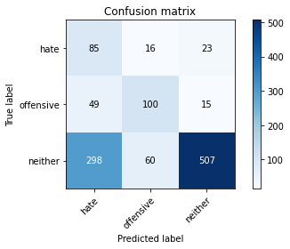

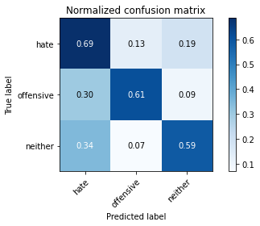

precision recall f1-score support

hate 0.20 0.69 0.31 124

offensive 0.57 0.61 0.59 164

neither 0.93 0.59 0.72 865

accuracy 0.60 1153

macro avg 0.57 0.63 0.54 1153

weighted avg 0.80 0.60 0.66 1153

average eval_loss: 1.8200681574385742, accuracy: 0.6001734605377277

3 run......

training 1 epoch...

70.36689710617065 seconds used......

1 training finished! average train loss: 1.012785652918475

evaluating...

Confusion matrix, without normalization

[[102 17 5]

[ 69 95 0]

[619 78 168]]

Normalized confusion matrix

[[0.82258065 0.13709677 0.04032258]

[0.42073171 0.57926829 0. ]

[0.71560694 0.09017341 0.19421965]]

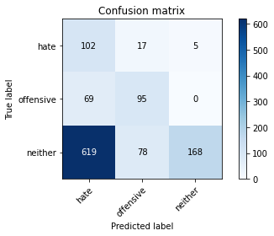

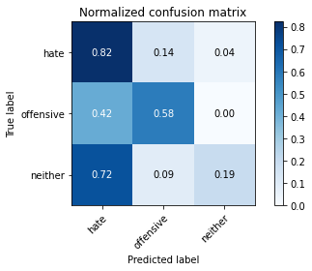

precision recall f1-score support

hate 0.13 0.82 0.22 124

offensive 0.50 0.58 0.54 164

neither 0.97 0.19 0.32 865

accuracy 0.32 1153

macro avg 0.53 0.53 0.36 1153

weighted avg 0.81 0.32 0.34 1153

average eval_loss: 0.9699077267071297, accuracy: 0.3165654813529922

training 2 epoch...

70.35288691520691 seconds used......

2 training finished! average train loss: 0.8631233526837259

evaluating...

Confusion matrix, without normalization

[[ 75 29 20]

[ 35 115 14]

[222 89 554]]

Normalized confusion matrix

[[0.60483871 0.23387097 0.16129032]

[0.21341463 0.70121951 0.08536585]

[0.2566474 0.10289017 0.64046243]]

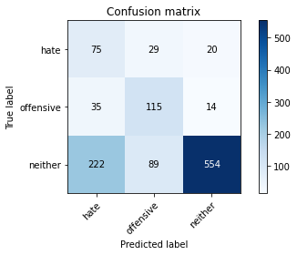

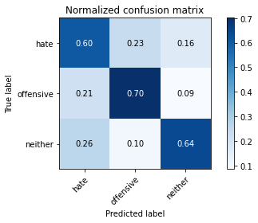

precision recall f1-score support

hate 0.23 0.60 0.33 124

offensive 0.49 0.70 0.58 164

neither 0.94 0.64 0.76 865

accuracy 0.65 1153

macro avg 0.55 0.65 0.56 1153

weighted avg 0.80 0.65 0.69 1153

average eval_loss: 0.8097081893476946, accuracy: 0.645273200346921

training 3 epoch...

70.35881471633911 seconds used......

3 training finished! average train loss: 0.7217694462410041

evaluating...

Confusion matrix, without normalization

[[100 15 9]

[ 62 89 13]

[455 57 353]]

Normalized confusion matrix

[[0.80645161 0.12096774 0.07258065]

[0.37804878 0.54268293 0.07926829]

[0.52601156 0.06589595 0.40809249]]

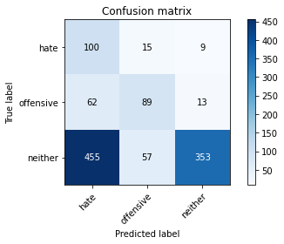

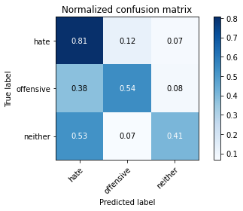

precision recall f1-score support

hate 0.16 0.81 0.27 124

offensive 0.55 0.54 0.55 164

neither 0.94 0.41 0.57 865

accuracy 0.47 1153

macro avg 0.55 0.59 0.46 1153

weighted avg 0.80 0.47 0.53 1153

average eval_loss: 0.9621378173088205, accuracy: 0.47007805724197743

training 4 epoch...

70.34109950065613 seconds used......

4 training finished! average train loss: 0.4938468423982461

evaluating...

Confusion matrix, without normalization

[[ 88 24 12]

[ 42 112 10]

[437 92 336]]

Normalized confusion matrix

[[0.70967742 0.19354839 0.09677419]

[0.25609756 0.68292683 0.06097561]

[0.50520231 0.10635838 0.38843931]]

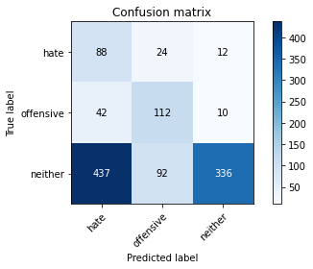

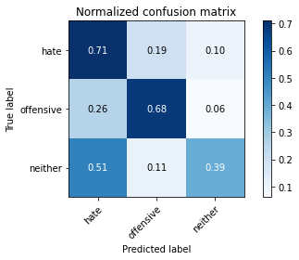

precision recall f1-score support

hate 0.16 0.71 0.25 124

offensive 0.49 0.68 0.57 164

neither 0.94 0.39 0.55 865

accuracy 0.46 1153

macro avg 0.53 0.59 0.46 1153

weighted avg 0.79 0.46 0.52 1153

average eval_loss: 1.2063500480405216, accuracy: 0.46487424111014747

training 5 epoch...

70.40559697151184 seconds used......

5 training finished! average train loss: 0.260592975653708

evaluating...

Confusion matrix, without normalization

[[ 83 23 18]

[ 41 112 11]

[427 84 354]]

Normalized confusion matrix

[[0.66935484 0.18548387 0.14516129]

[0.25 0.68292683 0.06707317]

[0.49364162 0.09710983 0.40924855]]

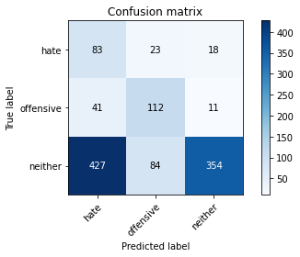

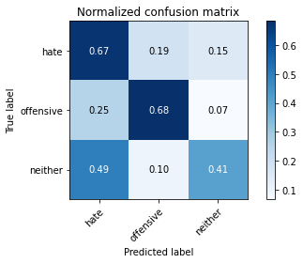

precision recall f1-score support

hate 0.15 0.67 0.25 124

offensive 0.51 0.68 0.58 164

neither 0.92 0.41 0.57 865

accuracy 0.48 1153

macro avg 0.53 0.59 0.47 1153

weighted avg 0.78 0.48 0.54 1153

average eval_loss: 1.4197630132066792, accuracy: 0.4761491760624458

training 6 epoch...

70.39206290245056 seconds used......

6 training finished! average train loss: 0.12001430083044051

evaluating...

Confusion matrix, without normalization

[[ 91 16 17]

[ 65 85 14]

[471 60 334]]

Normalized confusion matrix

[[0.73387097 0.12903226 0.13709677]

[0.39634146 0.51829268 0.08536585]

[0.54450867 0.06936416 0.38612717]]

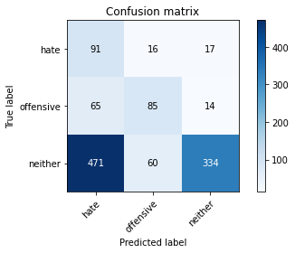

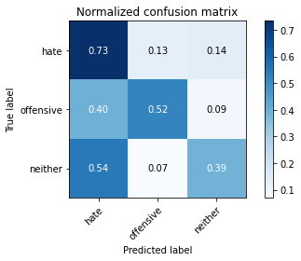

precision recall f1-score support

hate 0.15 0.73 0.24 124

offensive 0.53 0.52 0.52 164

neither 0.92 0.39 0.54 865

accuracy 0.44 1153

macro avg 0.53 0.55 0.44 1153

weighted avg 0.78 0.44 0.51 1153

average eval_loss: 1.8826117525840629, accuracy: 0.44232437120555074

training 7 epoch...

70.41866374015808 seconds used......

7 training finished! average train loss: 0.06921798373306436

evaluating...

Confusion matrix, without normalization

[[ 78 25 21]

[ 43 103 18]

[397 82 386]]

Normalized confusion matrix

[[0.62903226 0.2016129 0.16935484]

[0.26219512 0.62804878 0.1097561 ]

[0.45895954 0.09479769 0.44624277]]

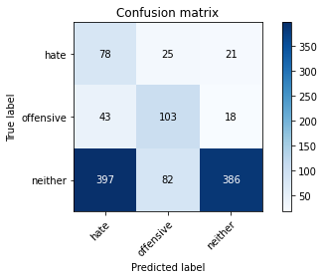

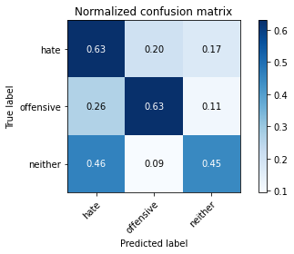

precision recall f1-score support

hate 0.15 0.63 0.24 124

offensive 0.49 0.63 0.55 164

neither 0.91 0.45 0.60 865

accuracy 0.49 1153

macro avg 0.52 0.57 0.46 1153

weighted avg 0.77 0.49 0.55 1153

average eval_loss: 2.021796131956166, accuracy: 0.49176062445793584

training 8 epoch...

70.35878396034241 seconds used......

8 training finished! average train loss: 0.04740451775848799

evaluating...

Confusion matrix, without normalization

[[ 70 19 35]

[ 34 102 28]

[305 62 498]]

Normalized confusion matrix

[[0.56451613 0.15322581 0.28225806]

[0.20731707 0.62195122 0.17073171]

[0.35260116 0.0716763 0.57572254]]

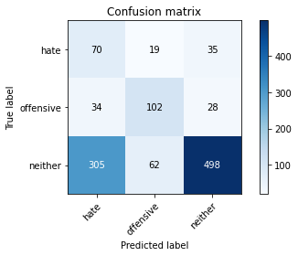

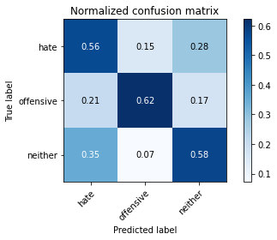

precision recall f1-score support

hate 0.17 0.56 0.26 124

offensive 0.56 0.62 0.59 164

neither 0.89 0.58 0.70 865

accuracy 0.58 1153

macro avg 0.54 0.59 0.52 1153

weighted avg 0.76 0.58 0.64 1153

average eval_loss: 1.6312103096781105, accuracy: 0.5810928013876843

training 9 epoch...

70.41467666625977 seconds used......

9 training finished! average train loss: 0.041035640832325

evaluating...

Confusion matrix, without normalization

[[ 72 25 27]

[ 32 115 17]

[352 91 422]]

Normalized confusion matrix

[[0.58064516 0.2016129 0.21774194]

[0.19512195 0.70121951 0.10365854]

[0.40693642 0.10520231 0.48786127]]

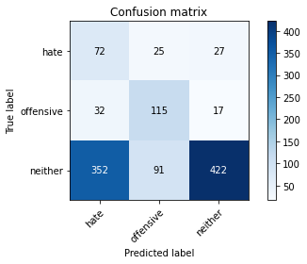

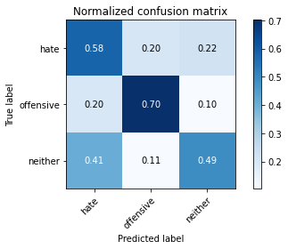

precision recall f1-score support

hate 0.16 0.58 0.25 124

offensive 0.50 0.70 0.58 164

neither 0.91 0.49 0.63 865

accuracy 0.53 1153

macro avg 0.52 0.59 0.49 1153

weighted avg 0.77 0.53 0.59 1153

average eval_loss: 2.0494690434686067, accuracy: 0.5281873373807459

training 10 epoch...

70.39407587051392 seconds used......

10 training finished! average train loss: 0.032595975388262775

evaluating...

Confusion matrix, without normalization

[[ 83 23 18]

[ 47 102 15]

[427 63 375]]

Normalized confusion matrix

[[0.66935484 0.18548387 0.14516129]

[0.28658537 0.62195122 0.09146341]

[0.49364162 0.07283237 0.43352601]]

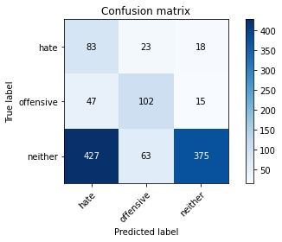

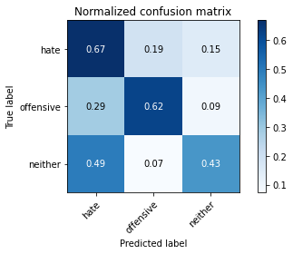

precision recall f1-score support

hate 0.15 0.67 0.24 124

offensive 0.54 0.62 0.58 164

neither 0.92 0.43 0.59 865

accuracy 0.49 1153

macro avg 0.54 0.57 0.47 1153

weighted avg 0.78 0.49 0.55 1153

average eval_loss: 2.4078792045856345, accuracy: 0.4856895056374675

4 run......

training 1 epoch...

70.36011528968811 seconds used......

1 training finished! average train loss: 0.9914298596836272

evaluating...

Confusion matrix, without normalization

[[102 17 5]

[ 54 105 5]

[670 58 137]]

Normalized confusion matrix

[[0.82258065 0.13709677 0.04032258]

[0.32926829 0.6402439 0.0304878 ]

[0.77456647 0.06705202 0.1583815 ]]

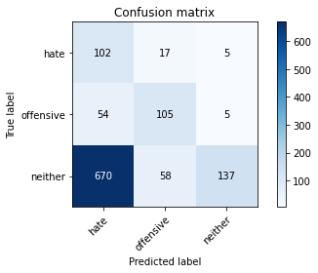

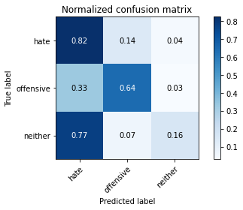

precision recall f1-score support

hate 0.12 0.82 0.21 124

offensive 0.58 0.64 0.61 164

neither 0.93 0.16 0.27 865

accuracy 0.30 1153

macro avg 0.55 0.54 0.37 1153

weighted avg 0.80 0.30 0.31 1153

average eval_loss: 1.000965540779048, accuracy: 0.2983521248915872

training 2 epoch...

70.45654106140137 seconds used......

2 training finished! average train loss: 0.8589695543050766

evaluating...

Confusion matrix, without normalization

[[101 17 6]

[ 55 100 9]

[526 47 292]]

Normalized confusion matrix

[[0.81451613 0.13709677 0.0483871 ]

[0.33536585 0.6097561 0.05487805]

[0.60809249 0.05433526 0.33757225]]

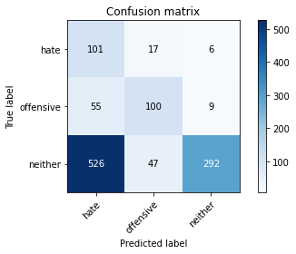

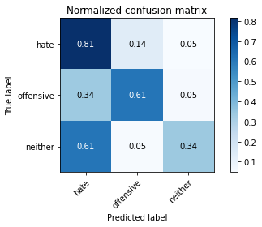

precision recall f1-score support

hate 0.15 0.81 0.25 124

offensive 0.61 0.61 0.61 164

neither 0.95 0.34 0.50 865

accuracy 0.43 1153

macro avg 0.57 0.59 0.45 1153

weighted avg 0.82 0.43 0.49 1153

average eval_loss: 0.9117423491231327, accuracy: 0.42758022549869906

training 3 epoch...

70.40368342399597 seconds used......

3 training finished! average train loss: 0.6861749161921796

evaluating...

Confusion matrix, without normalization

[[108 14 2]

[ 58 100 6]

[642 64 159]]

Normalized confusion matrix

[[0.87096774 0.11290323 0.01612903]

[0.35365854 0.6097561 0.03658537]

[0.74219653 0.07398844 0.18381503]]

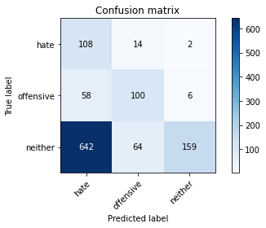

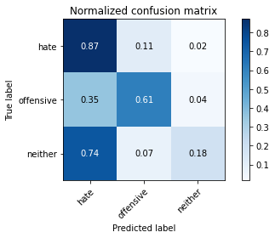

precision recall f1-score support

hate 0.13 0.87 0.23 124

offensive 0.56 0.61 0.58 164

neither 0.95 0.18 0.31 865

accuracy 0.32 1153

macro avg 0.55 0.55 0.37 1153

weighted avg 0.81 0.32 0.34 1153

average eval_loss: 1.356287889439484, accuracy: 0.3183000867302689

training 4 epoch...

70.4293920993805 seconds used......

4 training finished! average train loss: 0.42601403682714417

evaluating...

Confusion matrix, without normalization

[[ 94 18 12]

[ 47 109 8]

[501 66 298]]

Normalized confusion matrix

[[0.75806452 0.14516129 0.09677419]

[0.28658537 0.66463415 0.04878049]

[0.57919075 0.07630058 0.34450867]]

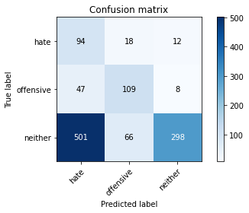

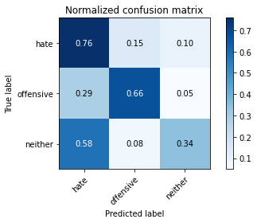

precision recall f1-score support

hate 0.15 0.76 0.25 124

offensive 0.56 0.66 0.61 164

neither 0.94 0.34 0.50 865

accuracy 0.43 1153

macro avg 0.55 0.59 0.45 1153

weighted avg 0.80 0.43 0.49 1153

average eval_loss: 1.4317826700621639, accuracy: 0.43451864700780574

training 5 epoch...

70.47581219673157 seconds used......

5 training finished! average train loss: 0.1990644637983115

evaluating...

Confusion matrix, without normalization

[[ 74 9 41]

[ 40 93 31]

[256 46 563]]

Normalized confusion matrix

[[0.59677419 0.07258065 0.33064516]

[0.24390244 0.56707317 0.18902439]

[0.29595376 0.05317919 0.65086705]]

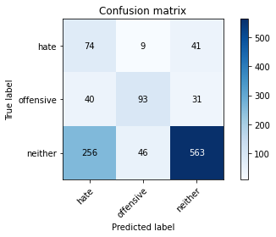

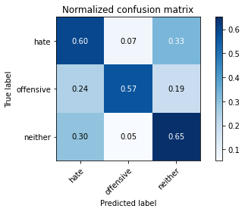

precision recall f1-score support

hate 0.20 0.60 0.30 124

offensive 0.63 0.57 0.60 164

neither 0.89 0.65 0.75 865

accuracy 0.63 1153

macro avg 0.57 0.60 0.55 1153

weighted avg 0.78 0.63 0.68 1153

average eval_loss: 1.130530023883129, accuracy: 0.6331309627059843

training 6 epoch...

70.43243336677551 seconds used......

6 training finished! average train loss: 0.11002554897485035

evaluating...

Confusion matrix, without normalization

[[100 15 9]

[ 49 104 11]

[487 66 312]]

Normalized confusion matrix

[[0.80645161 0.12096774 0.07258065]

[0.29878049 0.63414634 0.06707317]

[0.56300578 0.07630058 0.36069364]]

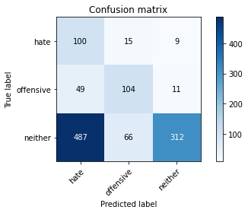

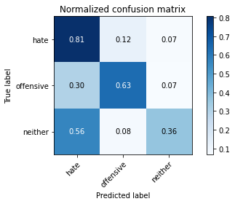

precision recall f1-score support

hate 0.16 0.81 0.26 124

offensive 0.56 0.63 0.60 164

neither 0.94 0.36 0.52 865

accuracy 0.45 1153

macro avg 0.55 0.60 0.46 1153

weighted avg 0.80 0.45 0.50 1153

average eval_loss: 2.377877175807953, accuracy: 0.44752818733738076

training 7 epoch...

70.3326153755188 seconds used......

7 training finished! average train loss: 0.08130135541848306

evaluating...

Confusion matrix, without normalization

[[ 96 14 14]

[ 43 108 13]

[426 62 377]]

Normalized confusion matrix

[[0.77419355 0.11290323 0.11290323]

[0.26219512 0.65853659 0.07926829]

[0.49248555 0.0716763 0.43583815]]

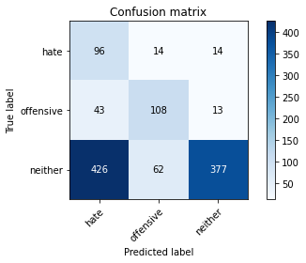

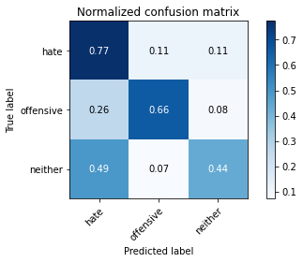

precision recall f1-score support

hate 0.17 0.77 0.28 124

offensive 0.59 0.66 0.62 164

neither 0.93 0.44 0.59 865

accuracy 0.50 1153

macro avg 0.56 0.62 0.50 1153

weighted avg 0.80 0.50 0.56 1153

average eval_loss: 2.2045336139613183, accuracy: 0.5039028620988725

training 8 epoch...

70.35028624534607 seconds used......

8 training finished! average train loss: 0.05394768019600417

evaluating...

Confusion matrix, without normalization

[[100 14 10]

[ 50 104 10]

[461 59 345]]

Normalized confusion matrix

[[0.80645161 0.11290323 0.08064516]

[0.30487805 0.63414634 0.06097561]

[0.53294798 0.06820809 0.39884393]]

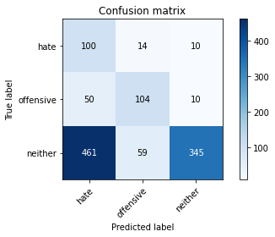

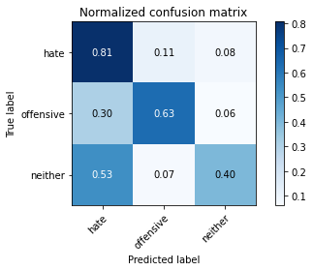

precision recall f1-score support

hate 0.16 0.81 0.27 124

offensive 0.59 0.63 0.61 164

neither 0.95 0.40 0.56 865

accuracy 0.48 1153

macro avg 0.57 0.61 0.48 1153

weighted avg 0.81 0.48 0.54 1153

average eval_loss: 2.536929496403398, accuracy: 0.4761491760624458

training 9 epoch...

70.39056944847107 seconds used......

9 training finished! average train loss: 0.036760324642749594

evaluating...

Confusion matrix, without normalization

[[101 12 11]

[ 63 90 11]

[443 50 372]]

Normalized confusion matrix

[[0.81451613 0.09677419 0.08870968]

[0.38414634 0.54878049 0.06707317]

[0.51213873 0.05780347 0.4300578 ]]

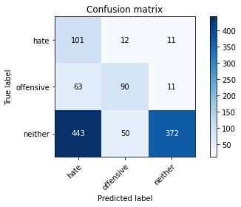

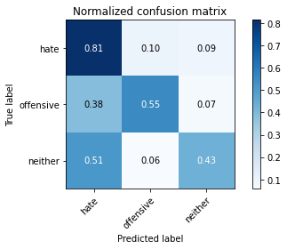

precision recall f1-score support

hate 0.17 0.81 0.28 124

offensive 0.59 0.55 0.57 164

neither 0.94 0.43 0.59 865

accuracy 0.49 1153

macro avg 0.57 0.60 0.48 1153

weighted avg 0.81 0.49 0.55 1153

average eval_loss: 2.5608577091118385, accuracy: 0.48829141370338247

training 10 epoch...

70.41318678855896 seconds used......

10 training finished! average train loss: 0.02815319465437261

evaluating...

Confusion matrix, without normalization

[[ 97 13 14]

[ 54 98 12]

[403 65 397]]

Normalized confusion matrix

[[0.78225806 0.10483871 0.11290323]

[0.32926829 0.59756098 0.07317073]

[0.46589595 0.07514451 0.45895954]]

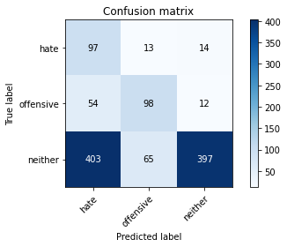

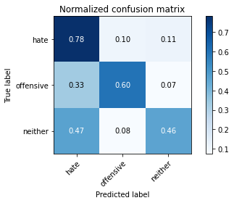

precision recall f1-score support

hate 0.18 0.78 0.29 124

offensive 0.56 0.60 0.58 164

neither 0.94 0.46 0.62 865

accuracy 0.51 1153

macro avg 0.56 0.61 0.49 1153

weighted avg 0.80 0.51 0.58 1153

average eval_loss: 2.3736058545523675, accuracy: 0.5134431916738942

5 run......

training 1 epoch...

70.36378765106201 seconds used......

1 training finished! average train loss: 0.9963594508312997

evaluating...

Confusion matrix, without normalization

[[ 93 27 4]

[ 40 121 3]

[549 103 213]]

Normalized confusion matrix

[[0.75 0.21774194 0.03225806]

[0.24390244 0.73780488 0.01829268]

[0.63468208 0.11907514 0.24624277]]

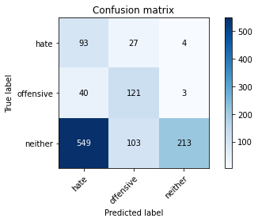

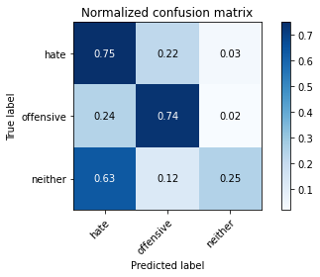

precision recall f1-score support

hate 0.14 0.75 0.23 124

offensive 0.48 0.74 0.58 164

neither 0.97 0.25 0.39 865

accuracy 0.37 1153

macro avg 0.53 0.58 0.40 1153

weighted avg 0.81 0.37 0.40 1153

average eval_loss: 1.0223414795152073, accuracy: 0.37033824804856896

training 2 epoch...

70.33809471130371 seconds used......

2 training finished! average train loss: 0.8539079878301847

evaluating...

Confusion matrix, without normalization

[[ 94 20 10]

[ 48 109 7]

[441 56 368]]

Normalized confusion matrix

[[0.75806452 0.16129032 0.08064516]

[0.29268293 0.66463415 0.04268293]

[0.50982659 0.06473988 0.42543353]]

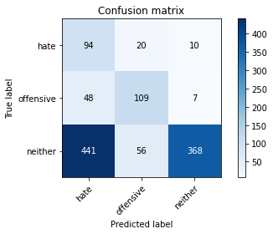

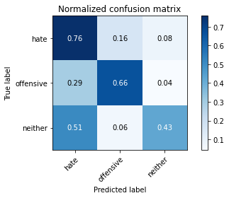

precision recall f1-score support

hate 0.16 0.76 0.27 124

offensive 0.59 0.66 0.62 164

neither 0.96 0.43 0.59 865

accuracy 0.50 1153

macro avg 0.57 0.62 0.49 1153

weighted avg 0.82 0.50 0.56 1153

average eval_loss: 0.8735455942564997, accuracy: 0.49522983521248914

training 3 epoch...

70.41434168815613 seconds used......

3 training finished! average train loss: 0.6877682817478975

evaluating...

Confusion matrix, without normalization

[[ 80 19 25]

[ 35 108 21]

[247 48 570]]

Normalized confusion matrix

[[0.64516129 0.15322581 0.2016129 ]

[0.21341463 0.65853659 0.12804878]

[0.28554913 0.05549133 0.65895954]]

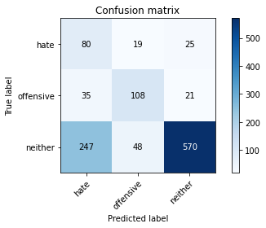

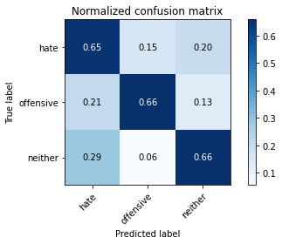

precision recall f1-score support

hate 0.22 0.65 0.33 124

offensive 0.62 0.66 0.64 164

neither 0.93 0.66 0.77 865

accuracy 0.66 1153

macro avg 0.59 0.65 0.58 1153

weighted avg 0.81 0.66 0.70 1153

average eval_loss: 0.7722751508499014, accuracy: 0.6574154379878577

training 4 epoch...

70.35658407211304 seconds used......

4 training finished! average train loss: 0.43093737835685414

evaluating...

Confusion matrix, without normalization

[[ 86 26 12]

[ 35 118 11]

[409 78 378]]

Normalized confusion matrix

[[0.69354839 0.20967742 0.09677419]

[0.21341463 0.7195122 0.06707317]

[0.47283237 0.09017341 0.43699422]]

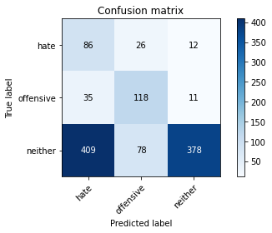

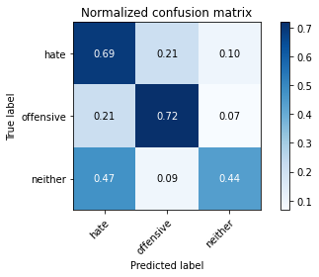

precision recall f1-score support

hate 0.16 0.69 0.26 124

offensive 0.53 0.72 0.61 164

neither 0.94 0.44 0.60 865

accuracy 0.50 1153

macro avg 0.55 0.62 0.49 1153

weighted avg 0.80 0.50 0.56 1153

average eval_loss: 1.3256241987491477, accuracy: 0.5047701647875108

training 5 epoch...

70.39912986755371 seconds used......

5 training finished! average train loss: 0.20266845722549728

evaluating...

Confusion matrix, without normalization

[[ 86 16 22]

[ 37 104 23]

[295 56 514]]

Normalized confusion matrix

[[0.69354839 0.12903226 0.17741935]

[0.22560976 0.63414634 0.1402439 ]

[0.34104046 0.06473988 0.59421965]]

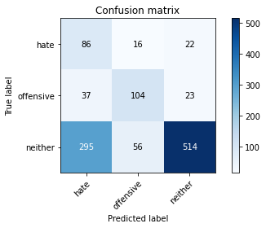

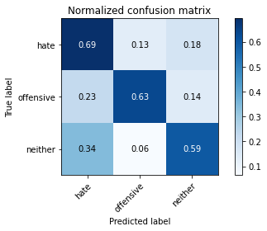

precision recall f1-score support

hate 0.21 0.69 0.32 124

offensive 0.59 0.63 0.61 164

neither 0.92 0.59 0.72 865

accuracy 0.61 1153

macro avg 0.57 0.64 0.55 1153

weighted avg 0.80 0.61 0.66 1153

average eval_loss: 1.3588235912651851, accuracy: 0.6105810928013877

training 6 epoch...

70.38383913040161 seconds used......

6 training finished! average train loss: 0.11257225381476539

evaluating...

Confusion matrix, without normalization

[[ 76 23 25]

[ 32 111 21]

[305 78 482]]

Normalized confusion matrix

[[0.61290323 0.18548387 0.2016129 ]

[0.19512195 0.67682927 0.12804878]

[0.35260116 0.09017341 0.55722543]]

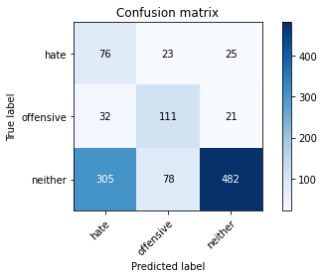

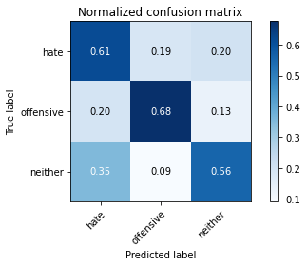

precision recall f1-score support

hate 0.18 0.61 0.28 124

offensive 0.52 0.68 0.59 164

neither 0.91 0.56 0.69 865

accuracy 0.58 1153

macro avg 0.54 0.62 0.52 1153

weighted avg 0.78 0.58 0.63 1153

average eval_loss: 1.6413831988285328, accuracy: 0.5802254986990459

training 7 epoch...

70.4027578830719 seconds used......

7 training finished! average train loss: 0.07254602332250215

evaluating...

Confusion matrix, without normalization

[[ 80 31 13]

[ 39 117 8]

[413 90 362]]

Normalized confusion matrix

[[0.64516129 0.25 0.10483871]

[0.23780488 0.71341463 0.04878049]

[0.47745665 0.10404624 0.41849711]]

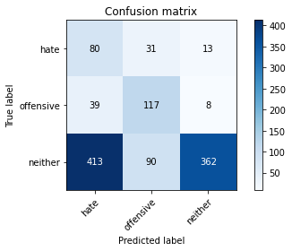

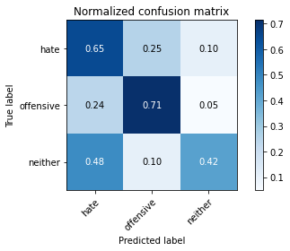

precision recall f1-score support

hate 0.15 0.65 0.24 124

offensive 0.49 0.71 0.58 164

neither 0.95 0.42 0.58 865

accuracy 0.48 1153

macro avg 0.53 0.59 0.47 1153

weighted avg 0.80 0.48 0.54 1153

average eval_loss: 2.3478795310546614, accuracy: 0.48482220294882916

training 8 epoch...

70.41998386383057 seconds used......

8 training finished! average train loss: 0.04907532334757326

evaluating...

Confusion matrix, without normalization

[[ 85 20 19]

[ 33 117 14]

[359 69 437]]

Normalized confusion matrix

[[0.68548387 0.16129032 0.15322581]

[0.20121951 0.71341463 0.08536585]

[0.4150289 0.07976879 0.50520231]]

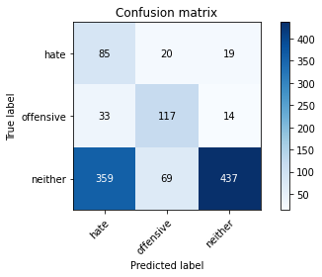

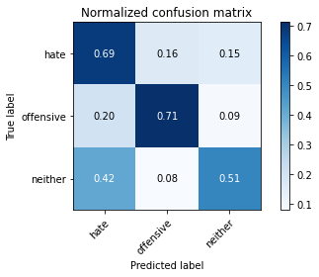

precision recall f1-score support

hate 0.18 0.69 0.28 124

offensive 0.57 0.71 0.63 164

neither 0.93 0.51 0.65 865

accuracy 0.55 1153

macro avg 0.56 0.63 0.52 1153

weighted avg 0.80 0.55 0.61 1153

average eval_loss: 2.154249906539917, accuracy: 0.5542064180398959

training 9 epoch...

70.39877414703369 seconds used......

9 training finished! average train loss: 0.05602703904878581

evaluating...

Confusion matrix, without normalization

[[ 92 19 13]

[ 43 104 17]

[420 61 384]]

Normalized confusion matrix

[[0.74193548 0.15322581 0.10483871]

[0.26219512 0.63414634 0.10365854]

[0.48554913 0.07052023 0.44393064]]

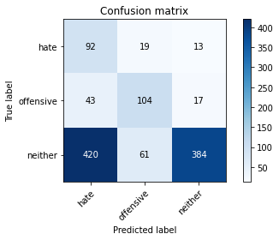

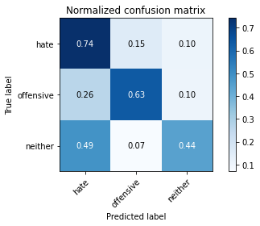

precision recall f1-score support

hate 0.17 0.74 0.27 124

offensive 0.57 0.63 0.60 164

neither 0.93 0.44 0.60 865

accuracy 0.50 1153

macro avg 0.55 0.61 0.49 1153

weighted avg 0.79 0.50 0.56 1153

average eval_loss: 2.2730664785566, accuracy: 0.5030355594102341

training 10 epoch...

70.38893985748291 seconds used......

10 training finished! average train loss: 0.04169078994545132

evaluating...

Confusion matrix, without normalization

[[ 79 23 22]

[ 40 108 16]

[367 66 432]]

Normalized confusion matrix

[[0.63709677 0.18548387 0.17741935]

[0.24390244 0.65853659 0.09756098]

[0.42427746 0.07630058 0.49942197]]

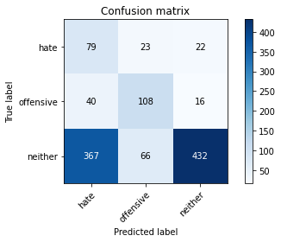

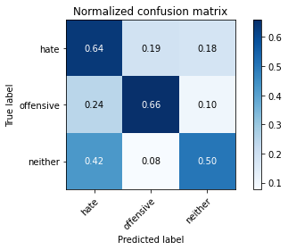

precision recall f1-score support

hate 0.16 0.64 0.26 124

offensive 0.55 0.66 0.60 164

neither 0.92 0.50 0.65 865

accuracy 0.54 1153

macro avg 0.54 0.60 0.50 1153

weighted avg 0.79 0.54 0.60 1153

average eval_loss: 2.1537184982464233, accuracy: 0.5368603642671292